Hamead Karimzad

108976200

Game Content Creation

DPS936

**Assignment 2: Amusement Park**

Table of Contents

# Part 1:

* 1. Train ride with at least one stop
  2. An animated plane ride
  3. A castle

# Part 2:

2.1 Lights and details

2.2 At least one camera

* 1. Move the train

# Part 1:

* 1. **-** Train ride with at least one stop

* 1. 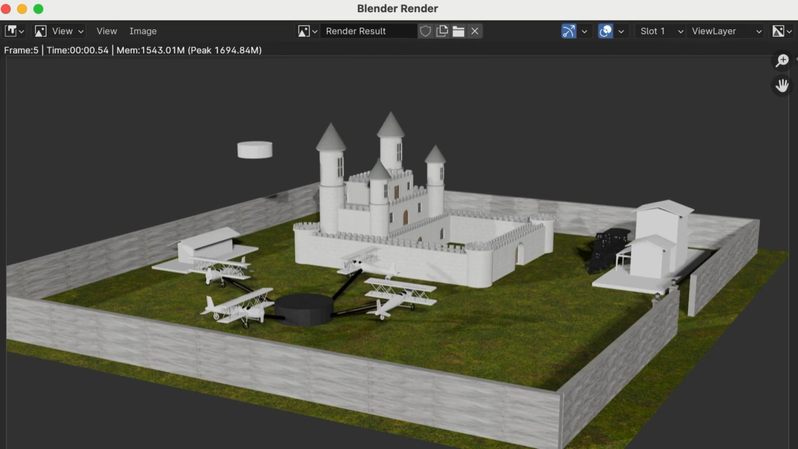**-** An animated plane ride
  2. **–** A castle

# Part 2:

**

2.2 At least one camera

* 1. Move the train

